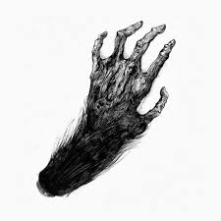
The Monkeys Paw
Sound Cue Sheet
Cue No. | Cue (Line in the script) | Description of Sound Effect | How long does it last?
E.G. | Beginning of Scene 1 | Stormy weather – Wind, Rain, Thunder | Fade out when actors speak
1

2

3

4

5

6

7

8

9

10

