Paisley Grammar School
Music
S2 Performing
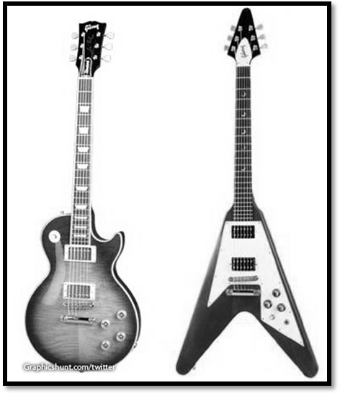

GUITAR

Guitar TAB Revision

Guitar TAB is 6 lines with each line representing a different string. The top line is the thinnest string (the one closest to the ground) and the bottom line is the thickest string (the one closest to the roof).

Thinnest - 1st --------------------------------
2nd --------------------------------
STRINGS 3rd ---------------------------------
4th ---------------------------------
5th ---------------------------------
Thickest - 6th --------------------------------

A number on a line, tells you what fret to put your finger on e.g. 0 means no frets, 1 means 1st fret, 4 means 4th fret etc.

1st Fret
2nd Fret
3rd Fret
4th Fret
5th Fret
1

Before you play the note, make sure you have checked these things:

What string is the number on? Remember: top line = bottom string.
What fret have you to play?
Make sure both of your hands match up on the same string.
Press the fret really hard.
Don’t use the same finger for every fret!
1st finger = 1st Fret, 2nd Finger = 2nd Fret, 3rd Finger = 3rd Fret
Practice your piece lots of times, making sure it is fluent, before asking your teacher to assess you.
If notes have a tail or are joined together then play them faster.

Piece 1
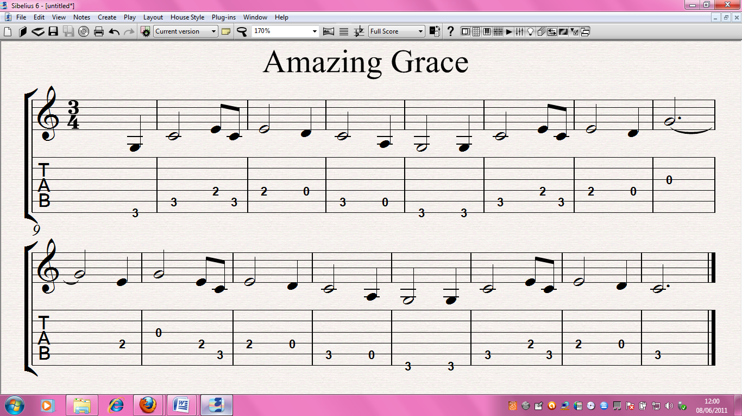
2
6th String 3rd Fret
This is a TRIPLET – play 3 even notes in the space of 2. Rhythm should sound like the word STRAW-BERR-Y.
Piece 2
Repeat line
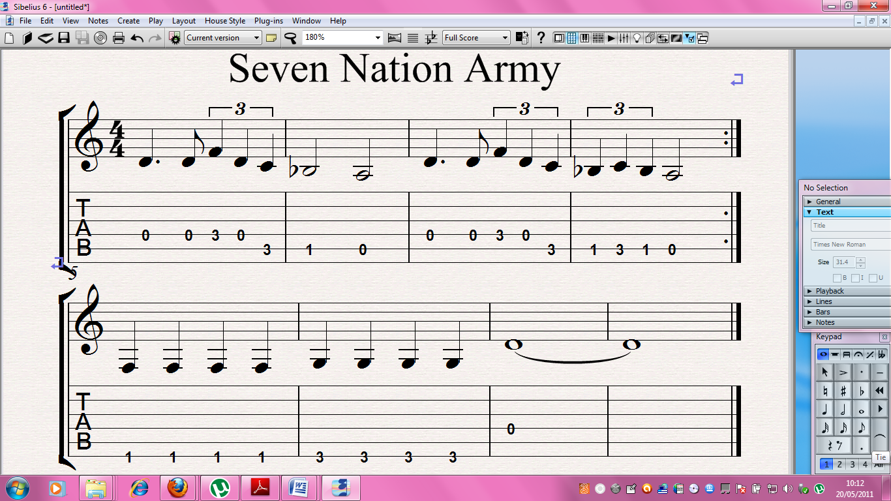

REMEMBER: If notes are joined together then play them faster.

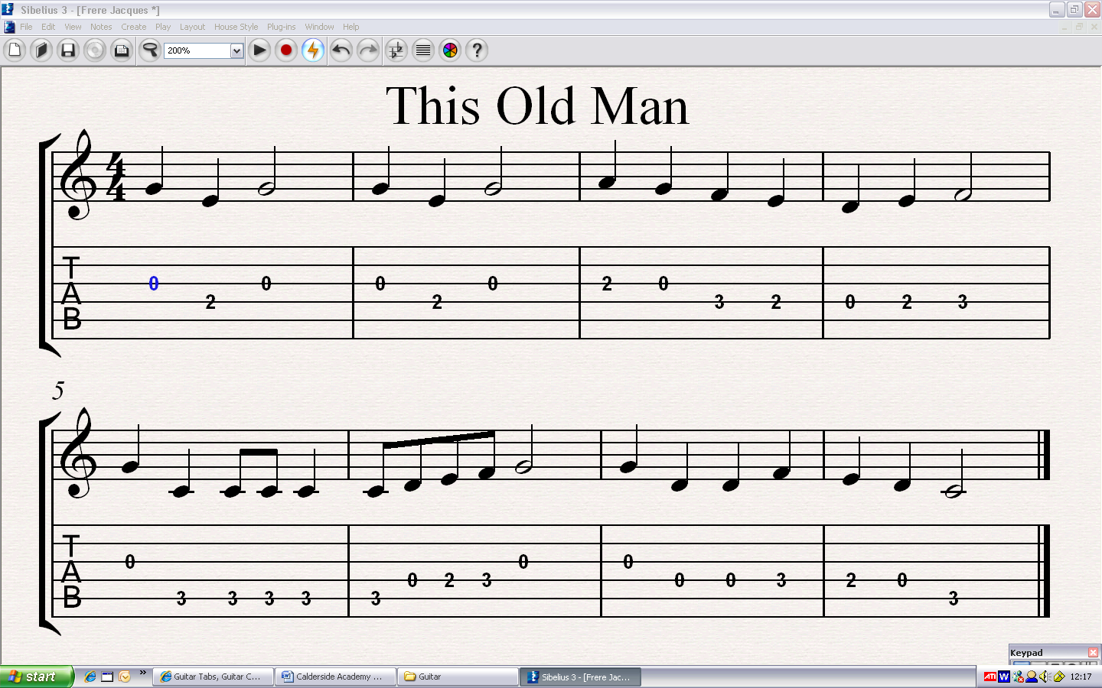Piece 3

3
Practice this bit lots of times until you can play it quickly and fluently.

Piece 4
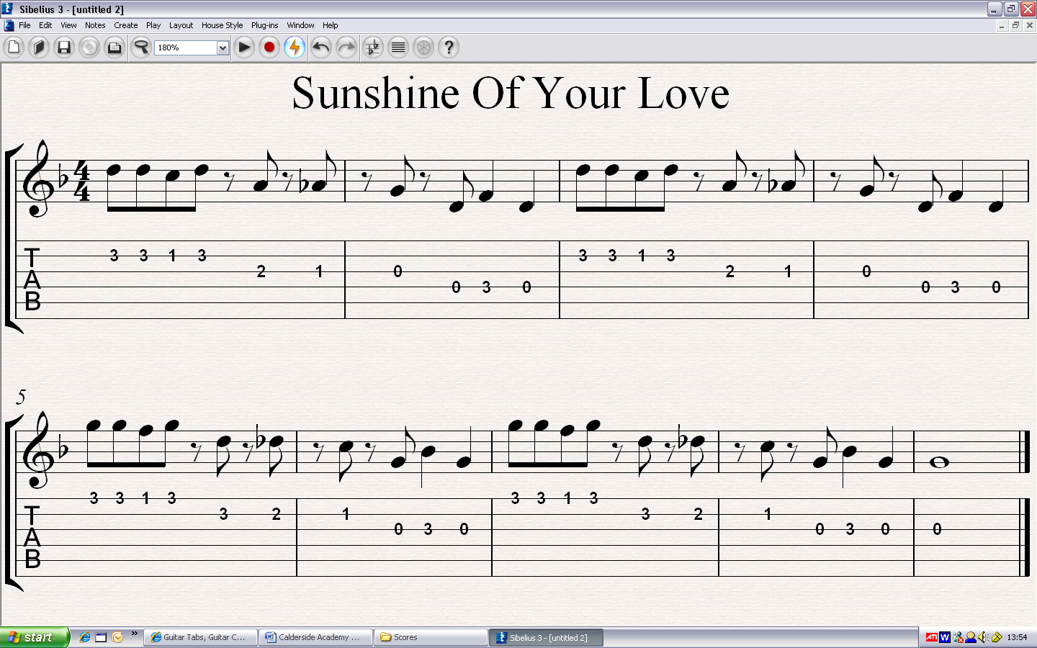

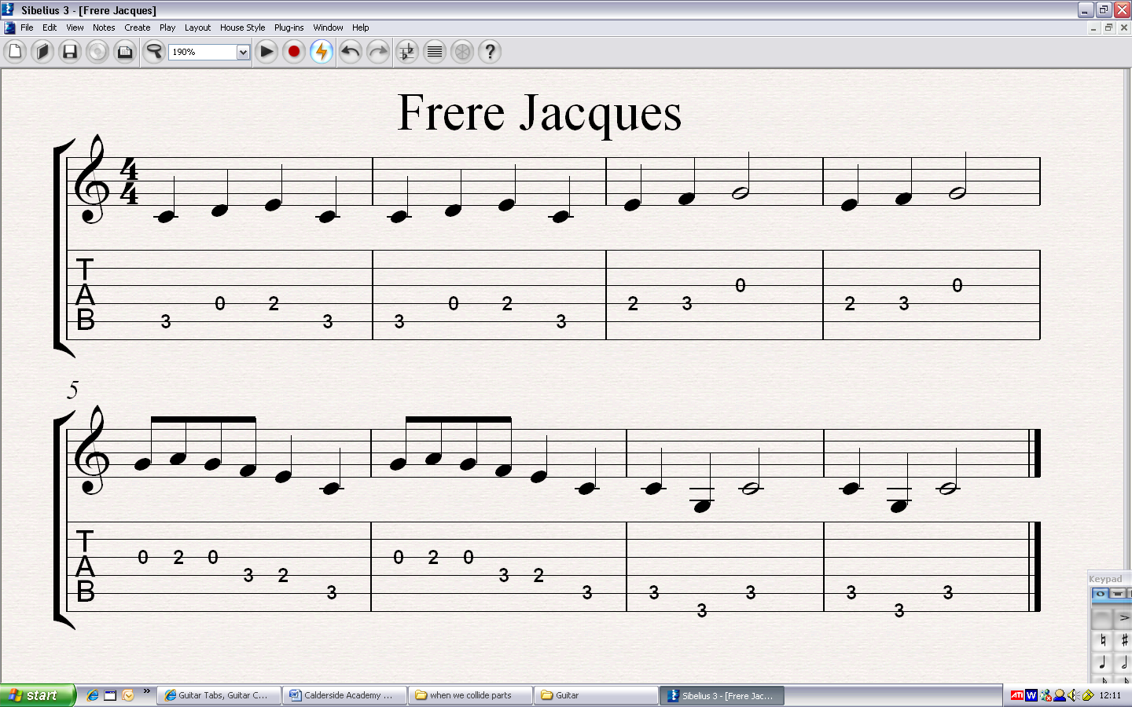Piece 5

4

Piece 6

Pattern 1

Same pattern as above but down a string

7
Back to pattern 1

5

Piece 7
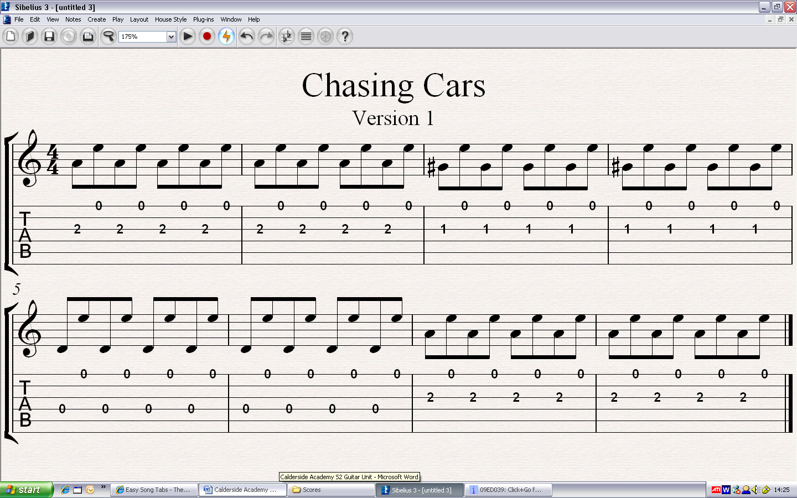

Piece 7 – version 2
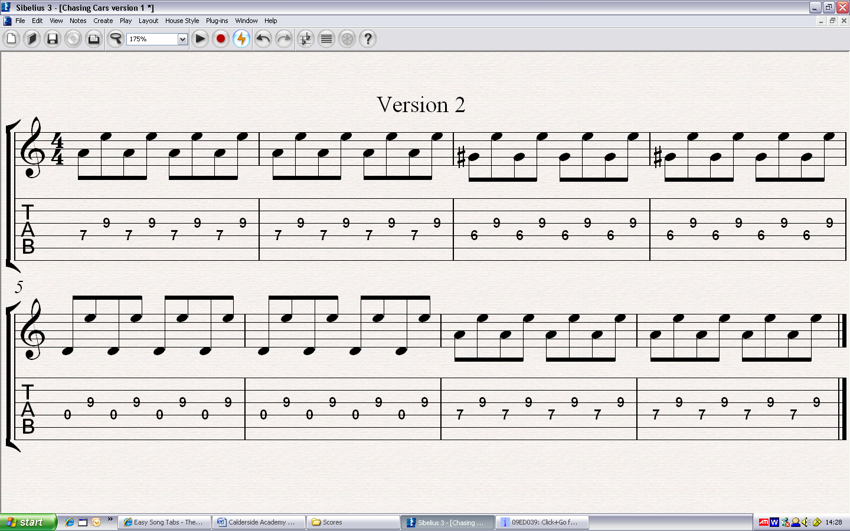

6

This song has a lot of rests in it where you don’t play anything. You must count these rests carefully to make sure the rhythms are correct. Here are the rests and the beats for each one.

= 4 = 2 = 1 = 1/2

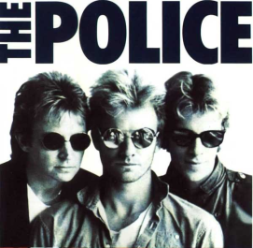
Piece 8

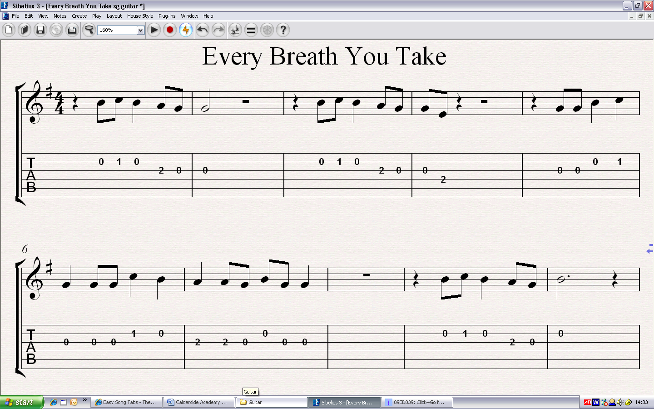

7

POWER CHORDS
Power chords are chords which only use 2 frets and are much easier to play than normal chords. They are used frequently in rock songs.

To play a power chord, you put your 1st finger on a fret and put either your 3rd finger or 4th finger (pinkie) 2 frets along and on the next string. Your teacher will demonstrate this.
1st Finger
4th Finger 2 frets along and 1 string down.
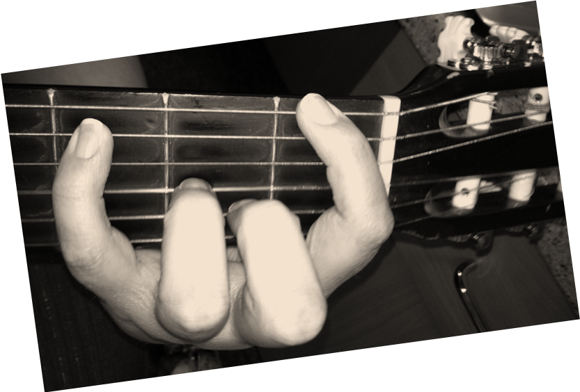

Using your thumb, finger or a plectrum, you then strum only the 2 strings that your fingers (on your other hand) are pressing frets down on.
8

Guitar frets work the same as notes on the piano, i.e. every fret is a different letter – E, F, F#, G, G#, A etc.

To play a certain chord, you put your 1st finger on the fret with the note of the chord you want.

Practice using your 1st finger to play the notes below using only the top 2 strings (strings 5 and 6).
E = top string no frets

1st
E
F
3
5
C
G
A
D

Chord | String | Fret
Em | 6 (top) | 0
F | 6 (top) | 1
G | 6 (top) | 3
A | 6 (top) | 5
C | 5 (second top) | 3
D | 5 (second top) | 5

9
We will begin with a song that has only 2 chords.
These chords are G and E.
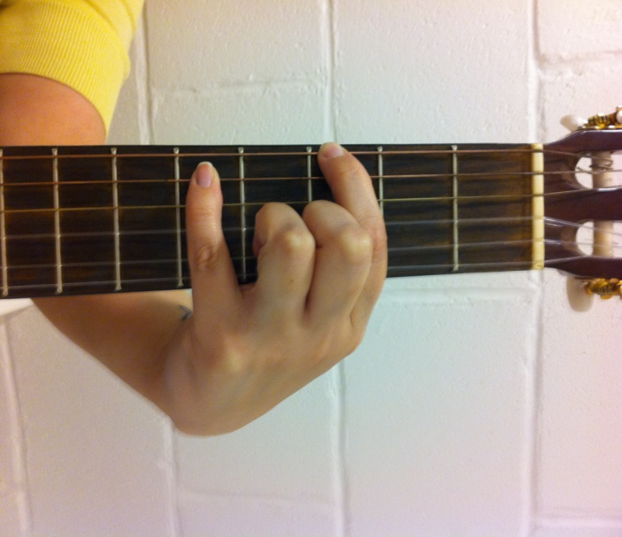
G – String 6, Fret 3
Strum strings 5 and 6
(top 2 strings)

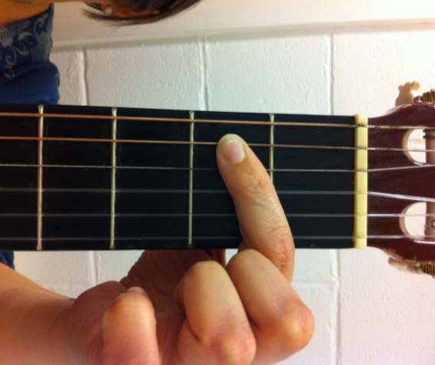
Em – Put your first finger on string 5 Fret 2 and strum strings 5 and 6
(top 2 strings)

Try using just your 1st finger (pointer) before trying to add in your pinkie.
Practice moving between these 2 chords lots of times. You need to be able to change quickly between them during the song.

- SONGBIRD
Repeat this pattern for the whole song.
G 2 3 4 5 6 7 8 Em 2 3 4 5 6 7 8
10
We will continue with another song that uses 2 chords but this time the chords are G and C.
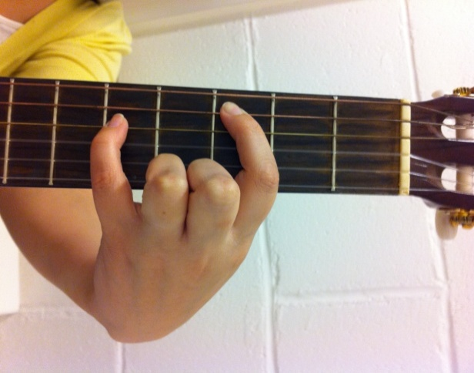 C – String 5, Fret 3
Strum strings 4 and 5

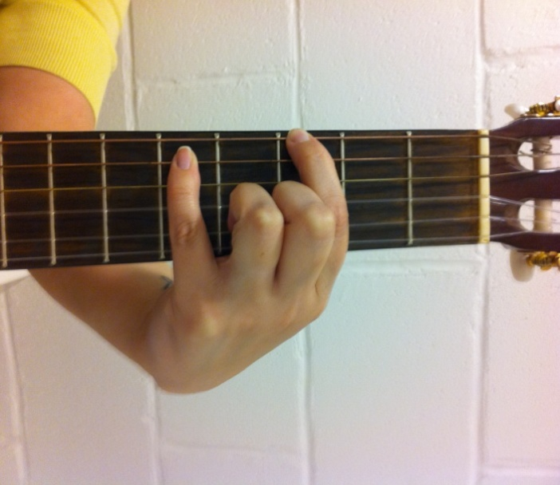
G – String 6, Fret 3
Strum strings 5 and 6
(top 2 strings)

Make sure you move both hands down a string to play the C Chord.

Billy Ray Cyrus - Achy Breaky
(Miley’s Dad) Heart
Repeat this pattern for the whole song.
C 2 3 4 5 6 7 8 G 2 3 4 5 6 7 8
11
The next song we will play has 3 chords – C, G and Em
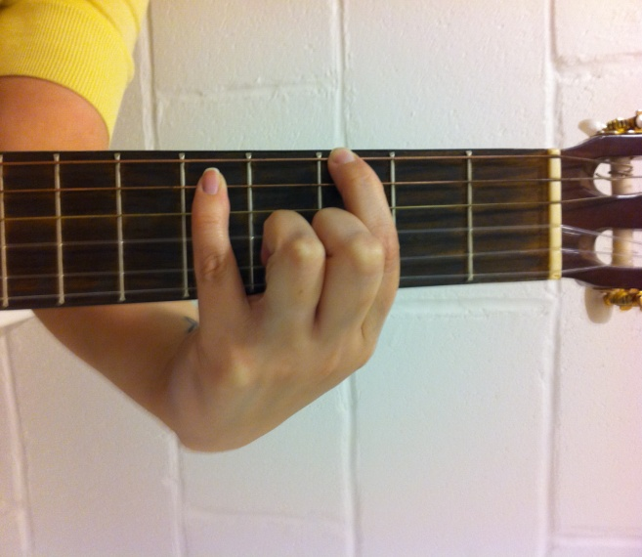 G – String 6, Fret 3
Strum strings 5 and 6
(top 2 strings)

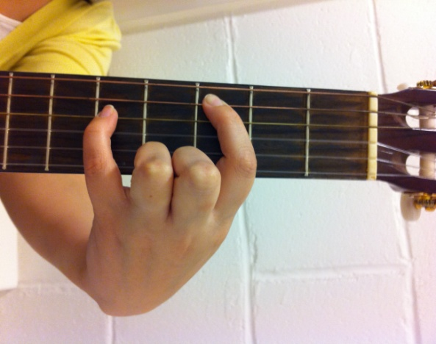 C – String 5, Fret 3
Strum strings 4 and 5

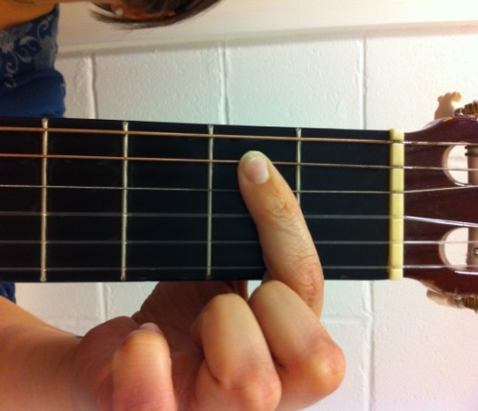 Em – Put your first finger on string 5 Fret 2 and strum strings 5 and 6
(top 2 strings)

G 2 3 4 C 2 3 4 Em 2 3 4 C 2 3 4
Repeat this pattern for the whole song.
12
We will now learn how to play the D power chord.
D – String 5, Fret 5
Strum strings 4 and 5

C – String 5, Fret 3
Strum strings 4 and 5

G – String 6, Fret 3
Strum strings 5 and 6
(top 2 strings)

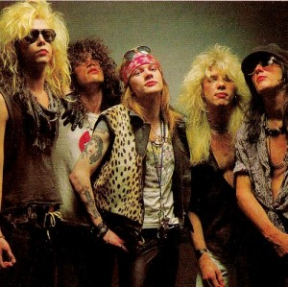

D 2 3 4 C 2 3 4 G 2 3 4 D 2 3 4
Repeat this pattern for the whole song.
13
The next song uses the same 3 chords as before.

D – String 5, Fret 5
Strum strings 4 and 5

C – String 5, Fret 3
Strum strings 4 and 5

G – String 6, Fret 3
Strum strings 5 and 6
(top 2 strings)

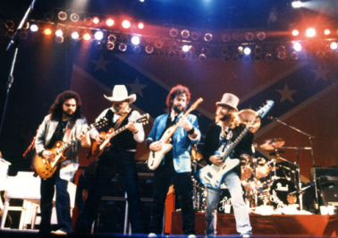

DD CC GG GG
Repeat this pattern for the whole song.
14

